Assignment Question Requirement

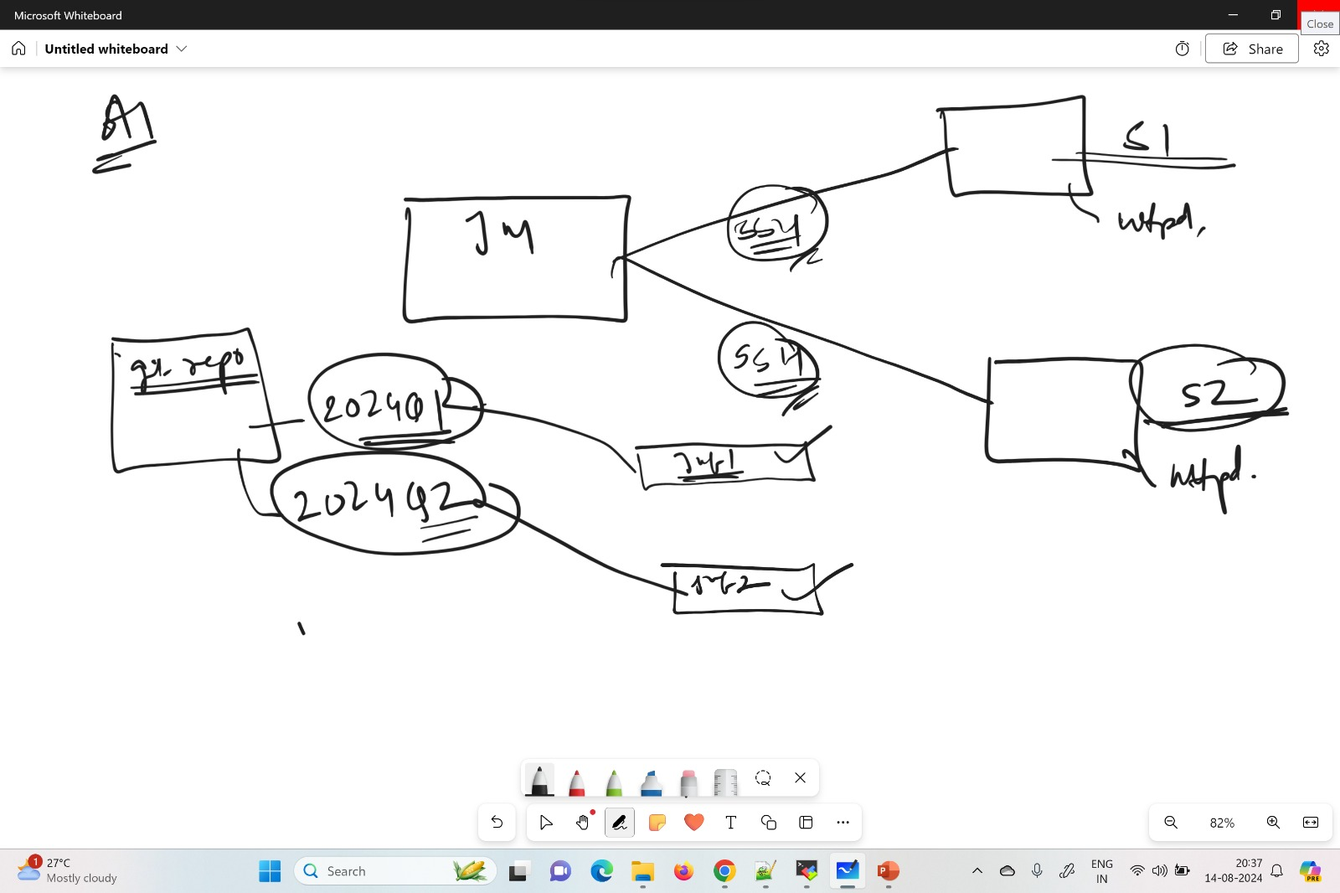

Step 1 : Launch Three ec2 (1-jenkins Master and 2 –Slaves)

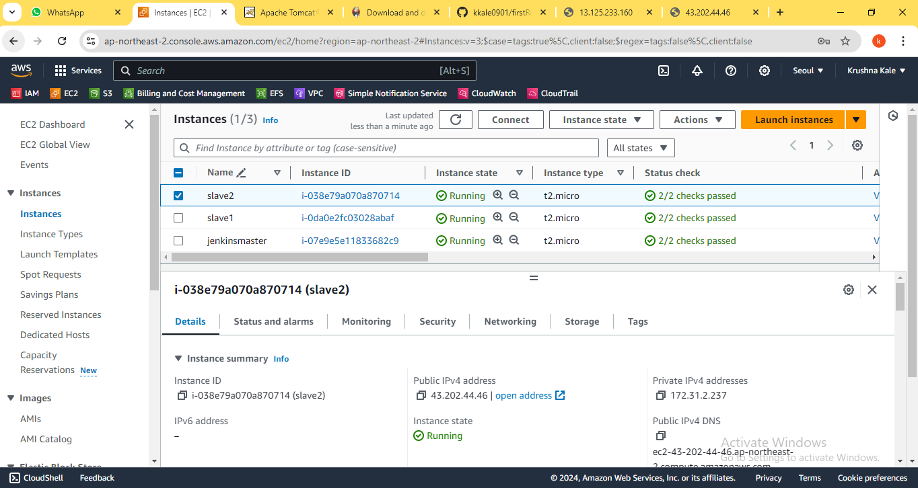

Step 2 : Created Node (connection through SSH)

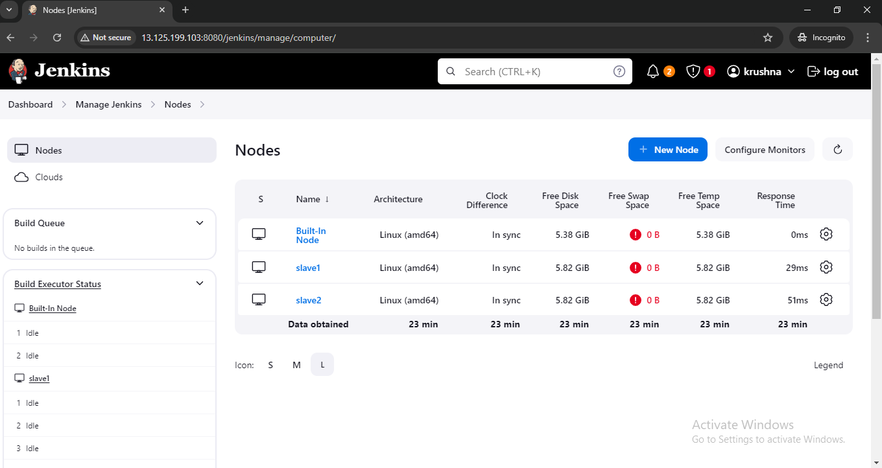

Step 3: Created two jobs (job1- run on slave1 and job2- run on slave2)

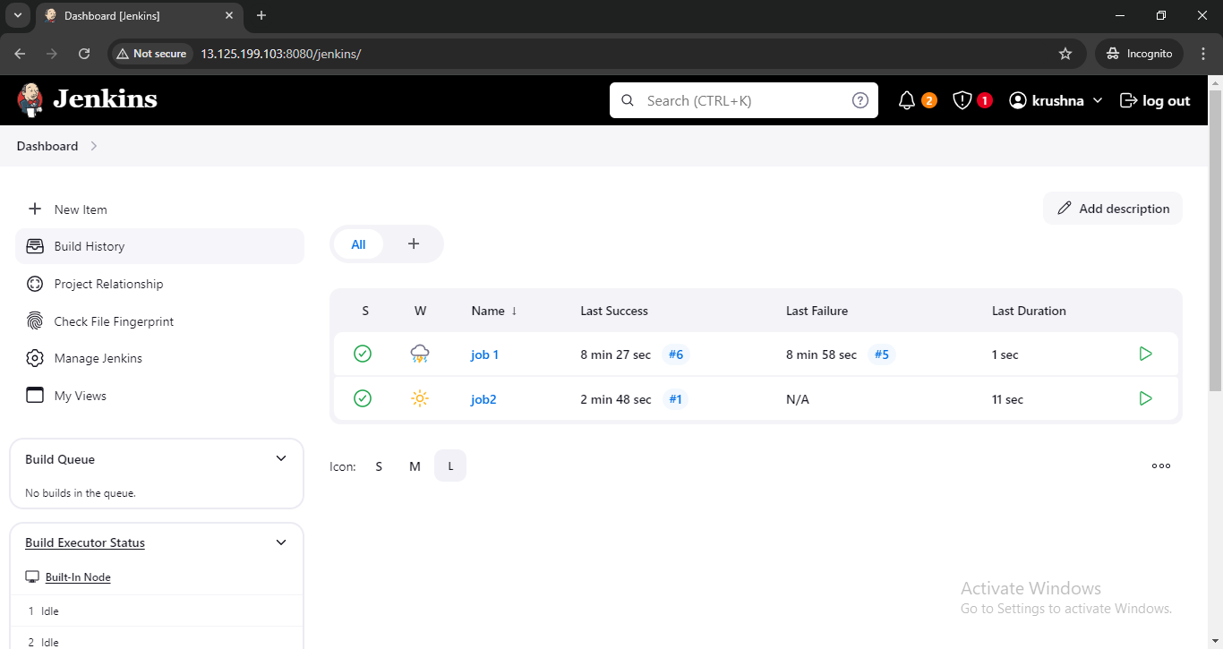

Step 4: Job1 on build successfully

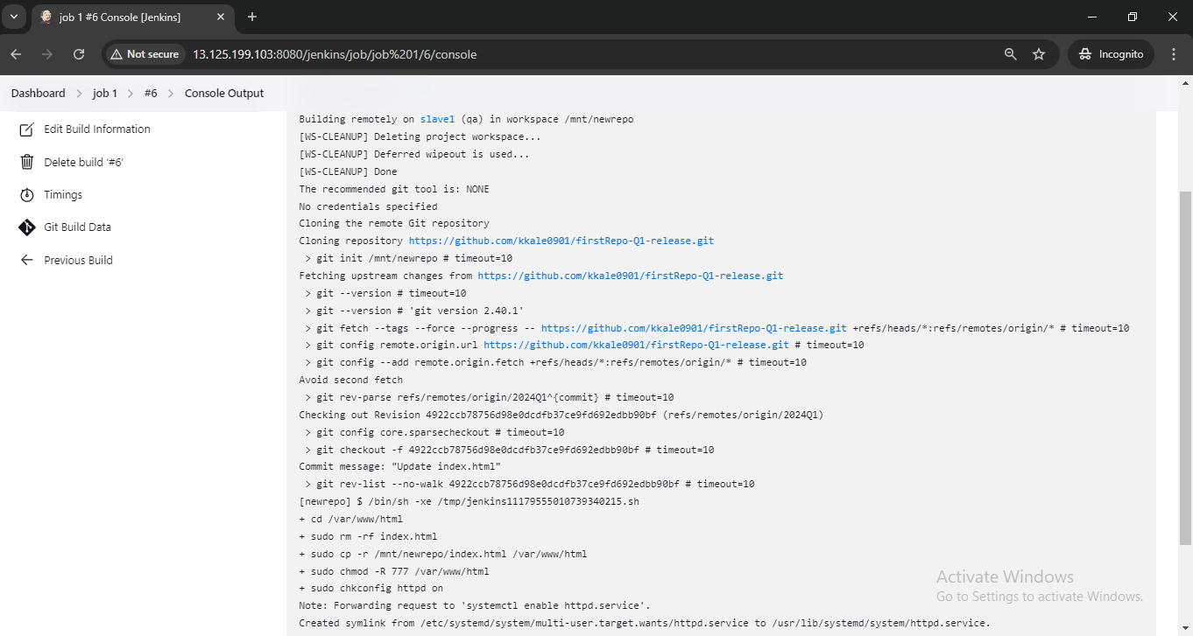

Step 5: Job2 on build successfully

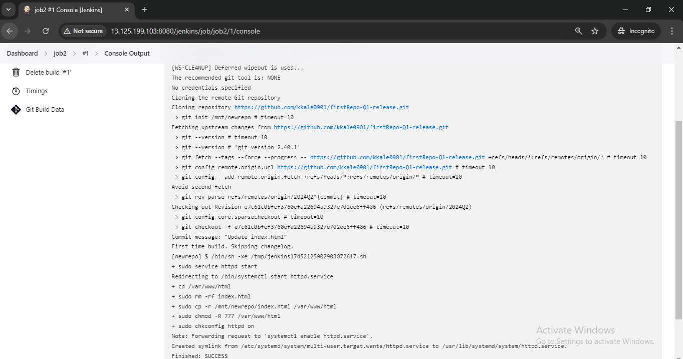

Step 6: 2024Q1 branch Website host

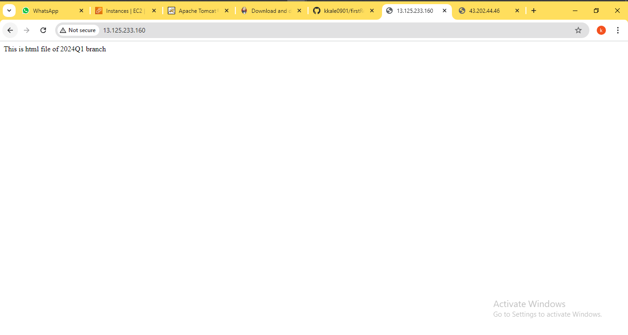

Step 7: 2024Q2 branch Website host

